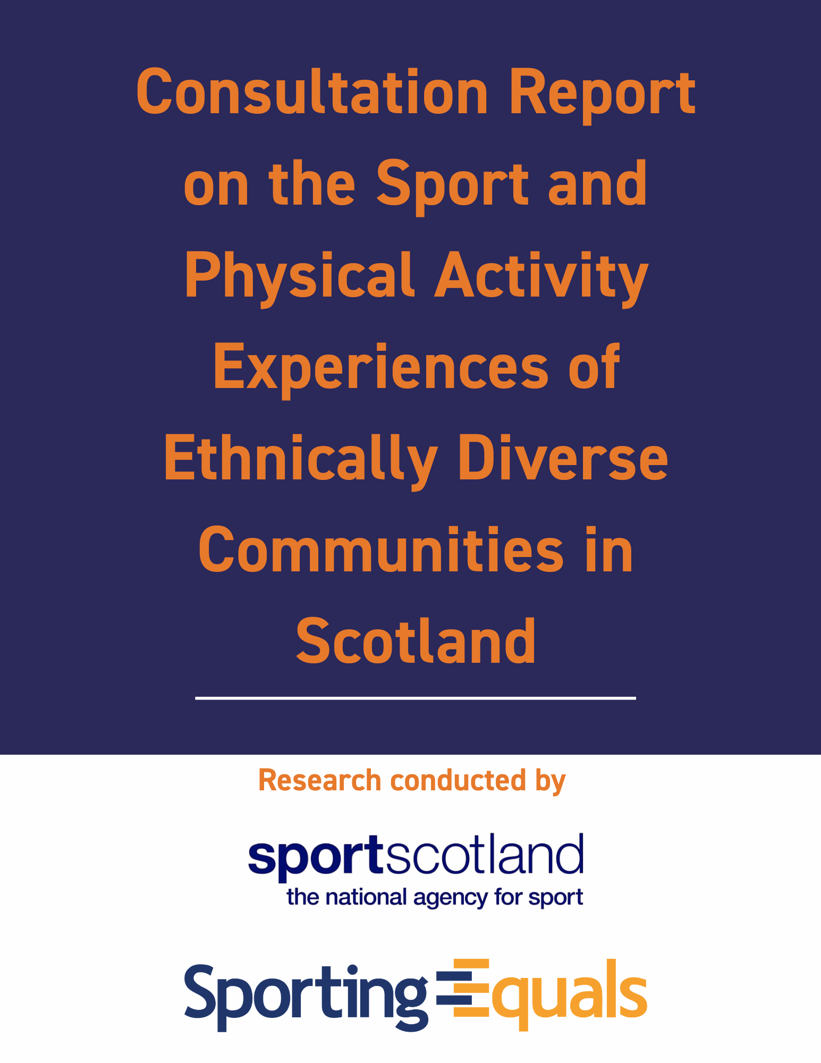

Contents

Executive Summary | 2
Introduction | 5
Methodology | 5
Limitations | 5
Key Findings | 6
Section 1. Reasons for and barriers to participation  Economic barriers to participation  Structural barriers to participation  Intersectional cultural barriers to participation  Sport Development & Sport for Development – Different Needs, Different Structure | 9  9  10  11  12
Section 2. Relationship Building, Bureaucracy and Communication | 14
Section 3. Pathways to success | 16
Section 4. Wider attitudes towards EDI as practice  Conclusion | 18  20

Executive Summary

sportscotland commissioned Sporting Equals to undertake consultation with community groups and individuals from ethnically diverse communities to explore their experiences of engaging with sport and physical activity and the structures that support sports and physical activity participation within Scotland.
The findings from the consultation are divided into the following themes:
- Reasons for and barriers to participation;
- Relationship Building, Bureaucracy and Communication;
- Pathways to success;
- Wider attitudes towards EDI as practice (core understandings of diversity).
These topics emerged as key aspects from focus groups, one-to-one interviews and meetings which took place with individuals from various ethnic backgrounds and a variety of organisations that engage with ethnically diverse communities through sport.
Reasons for and barriers to participation
- Barriers to participation can be seen as primarily economic, structural and cultural - including personal and organisational constraints.
- Economic barriers relate to the connection between ethnicity and economic deprivation and to access to funding.
- Structural barriers include access to appropriate facilities for Community Sport Organisations and embedding positive work with ethnically diverse communities within sport.
- Longstanding cultural barriers remain that are connected to ignorance or prejudice within the wider population.
- There are distinctions between the challenges faced by Community Sport Organisations and sport specific clubs in widening participation.
The role of Community Sport Organisations in widening participation amongst ethnically diverse communities is often not recognised. Funding structures need to be reassessed to account for such organisations who do not necessarily have a direct affiliation with a particular sport but who are widening participation whilst meeting other social cohesion objectives. Accessing facilities is particularly challenging for CSOs and when support is offered there can be suspicion about the mutual benefits. Inclusion is often seen as tokenistic, not informed by lived experience and not embedded within sporting structures.
Furthermore, there is a perspective from within more established ethnically diverse communities, such as those of South Asian heritage, that their needs are less recognised compared to other more recent migrant populations.
Relationship Building, Bureaucracy and Communication
- Engaging with ethnically diverse communities involves building trust and takes time.
- Processes for funding from grant making bodies or trusts are seen as well-structured and supportive, (compared to sporting organisations), with dedicated grant officers support a more personal relationship.
- There is a lack of awareness of what sportscotland do or deliver. Sport Governing Bodies are often seen as too sport specific for the needs of community sport organisations.
- SGBs/sportscotland misunderstand community sport organisations - the groups represented are already engaging diverse populations in sport and want to do more but are not recognised or supported as such.
- There is a lack of information (or problems communicating information) about what SGBs/sportscotland actually can do for community sport organisations.
- With SGBs/sportscotland, communication is a problem because of the lack of personal engagement and the presence of too many intermediaries – there is a desire for a more direct, personal relationship.
Widening participation often comes down to the dedication of particular members of sports clubs and their desire to spend time building relationships. This can be difficult to sustain without specific support to build such capacity. Often existing methods, such as Active Schools, are criticised for being overly bureaucratic and for not recognising the existing work that is taking place in the community.
In contrast, the process of engaging with community development focused funders is highlighted as good practice that sportscotland could adopt. This could involve facilitating relationships between sports clubs that show enthusiasm for widening their membership amongst ethnically diverse communities and community sport organisations which have the cultural experience and trust within communities.
Pathways to success
- Pathways into sport are not well enough established or understood.
- Minority led organisations want to build relationships that can be of mutual benefit. A pragmatic approach is taken by some that if an SGB wants to meet specific targets they should, ‘talk to us and we will use our networks’. And in return support the organisations themselves to grow those networks and offer what they know their participants wants or/needs in order to develop.
- Once participants are involved with sporting bodies (in leadership or coaching positions) support them to maintain their community roots and culture and give back
Historically there are cultural barriers that prevent sport from being seen as a legitimate pathway to success amongst some ethnically diverse communities. This is related to the lack of role models from these communities within non-playing roles and in some sports more widely at the elite level, as well as within grassroots sport.
It is also the result of funding problems that Community Sport Organisations face in trying to sustain and expand their offer when participants show potential or a desire to progress. Some Community Sport Organisations recognise the need to work in partnership but at the same time are frustrated that they are approached in order to reach certain targets rather than a genuine need to support them and the community.
Wider attitudes towards EDI as practice
- There is a distinction between longer-term ethnically diverse communities and more newly arrived groups in terms of their needs, lived experiences and solutions to persistent issues of prejudice within sport.
- There is a feeling from long term settled South Asian communities that they are perceived to be part of the mainstream and therefore funding is being redirected to other ethnically diverse communities - particularly new black communities.
- EDI is a shield for sport organisations to tick boxes and suggest they are doing something without any action on the ground - SGBs need to get out and meet people and build relationships particularly with gatekeepers to those communities.
- Exploring diversity within sport is challenging but an open and honest approach is necessary with clear and transparent leadership from the top to help build trust.
There is a view that EDI is a shield that operates through policy documentation. Positive gains over the years are acknowledged, however genuine concern exists over the continuance of structural racism and inequalities. Proactively recruiting and encouraging involvement of people from ethnically diverse community members at all levels of sport is seen as a necessary part of widening involvement at the participatory level.
Conclusion
Sport organisations need as clear a picture as possible of the local community landscape, who is being engaged and where this is being delivered to help create wider pathways and opportunities. sportscotland needs to create greater visibility around its role and work that is being delivered.
Alongside this Community Sports organisations need to be adequately supported through funding and facility provision to help support engagement and widening sports provision across all ethnically diverse communities.
There is a need to raise awareness around subtle forms of racial prejudice, microaggressions and have mechanisms in place where organisations are trained and supported to tackle these issues. Alongside this greater transparency is needed around how funding is distributed and widening of access and support around this.
Diversity and Inclusion Action Plans should help monitor recruitment, data collection, and workforce profiling making everyone responsible for EDI - not just a particular job role or department. This needs to be supported with diversifying workforce, volunteer, coaching and player profiles and monitored to support wider systemic change.

Consultation Report on the Sport and Physical activity Experiences of Ethnically diverse communities in Scotland

Introduction
sportscotland commissioned Sporting Equals to undertake consultation with community groups and individuals from ethnically diverse communities to explore their experiences of engaging with sport and physical activity and the structures that support sports and physical activity participation within Scotland.
sportscotland is the national body which oversees sport provision in Scotland and distributes funding to different sports through the Sport Governing Bodies (SGBs) who have responsibility for the development of and access to their specific sport. Alongside the mainstream structures are a number of Community Sport Organisations (CSOs) that use sport as a tool for engagement and exist outside of the traditional mainstream structures.
Many of these CSOs have emerged from ethnically diverse communities explicitly to serve the needs of those communities, historically because they were not supported by the traditional structures of sport.
Methodology
sportscotland were engaged with the development of a focus group framework which covered some key themes including accessing and finding out about sport/physical activity opportunities, barriers, challenges, understanding and engagement in existing sportscotland programmes. Alongside ideas around how sport in Scotland can be made more inclusive for ethnically diverse communities.
Two face to face focus groups took place in Edinburgh and Glasgow which engaged 7 community organisations, this was supplemented by a further 4 one to one interviews over the telephone and two more informal face to face visits in Glasgow, engaging with a total of 13 community organisations. The sample represented the views of a wide range of people including but not limited to South Asian, (Pakistani, Indian), Black African, Caribbean and Sudanese, along with Middle Eastern and White Scottish people from Muslim, Sikh, and Christian backgrounds. Most organisations worked with more than one ethnic group and were open to all based on the local profile of the area, although they may have a predominance of one ethnic group in light of how they were set up and have evolved over time.
Limitations
It is worth pointing out that a possible limitation to this consultation is the age profile of participants who were more representative of a generation in their 40s and 50s. The consequence of this is that their views are informed by many years of battling against what they perceive as cultural ignorance hidden behind bureaucratic procedures. That does not mean these views are invalid but these issues did not emerge as strongly from discussions with interviewees in their 20s, who were more supportive of the attitude that sports authorities took and understood better the structures within which they were working. There is also a lack of female participants – which is, in itself, a reflection of gendered engagement.
Key Findings
The findings from the consultation are divided into the following themes:
- Reasons for and barriers to participation;
- Relationship Building, Bureaucracy and Communication;
- Pathways to success;
- Wider attitudes towards EDI as practice (core understandings of diversity).
Research participants that represented organisations fell into two distinct categories:
1) sport organisations (that exist to provide sporting opportunities in line with the conventional sports development model predominantly at the foundation, participation and performance levels – with the possibility of progressing to elite level).
2) community organisations (that offer various support for, in this case, ethnically diverse communities, of which sport is one that is often tied, for example, to social inclusion/cohesion, employability or community health objectives.
The former tend to be funded by a combination of membership subscriptions and grants from SGBs. The latter tend to rely on funding from grant giving.
The four general themes that emerged from the focus groups and interviews will be expanded upon in the rest of the report with reference to the voices of those participating in the consultation. However, the key messages that emerge are as follows:
1) Reasons for and barriers to participation
- Barriers to participation can be seen as primarily economic, structural and cultural - including personal and organisational constraints.
- Economic barriers relate to the connection between ethnicity and economic deprivation and to organisational flows of funding.
- Structural barriers include access to appropriate facilities for Community Sport Organisations and embedding positive work with ethnically diverse communities within sport.
- Longstanding cultural barriers remain that are connected to ignorance or prejudice within the wider population.
- There are distinctions between the challenges faced by Community Sport Organisations and sport specific clubs in widening participation.
The role of Community Sport Organisations in widening participation amongst ethnically diverse communities is often not recognised. Funding structures need to be reassessed to account for such organisations who do not necessarily have a direct affiliation with a particular sport but who are widening participation whilst meeting other social cohesion objectives. Accessing facilities is particularly challenging for CSOs and when support is offered there can be suspicion about the mutual benefits. Inclusion is often seen as tokenistic, not informed by lived experience and not embedded within sporting structures. Furthermore, there is a perspective from within established ethnically diverse communities, such as those with South Asian heritage, that their needs are lessened due to their longevity and more recent migrant populations are being favoured.
2) Relationship Building, Bureaucracy and Communication
- Engaging with ethnically diverse communities involves building trust and takes time.
- Processes for funding from trusts are seen as well-structured and supportive (unlike sporting organisations) with dedicated grant officers and a more personal relationship.
- There is a lack of awareness of what sportscotland do and that Sport Governing Bodies are too sport specific for the needs of community sport organisations.
- SGBs/sportscotland misunderstand community sport organisations - the groups represented are already engaging diverse populations in sport and want to do more but are not recognised or supported as such.
- There is a lack of information (or problems communicating information) about what SGBs/sportscotland actually do or can do for community sport organisations.
- With SGBs/sportscotland, communication is a problem because of the lack of personal engagement and the presence of too many intermediaries – there is a desire for a more direct, personal relationship.
Widening participation often comes down to the dedication of particular members of sports clubs and their desire to spend time building appropriate relationships. This can be difficult to sustain without specific support to build such capacity. However, existing methods, such as Active Schools, are criticised for being overly bureaucratic and again for not recognising the existing work that is taking place in this cultural space. In contrast, the process of engaging with community development focused funders is highlighted as good practice that sportscotland should adopt.
3) Pathways to success
- Pathways into sport are not well enough established or understood.
- Minority led organisations want to build relationships that can be of mutual benefit. A pragmatic approach is taken by some that if an SGB wants to meet specific targets they should, ‘talk to us and we will use our networks’. And in return support the organisations themselves to grow those networks and offer what they know their participants want/need in order to develop.
- Once participants are involved with sporting bodies (in leadership or coaching positions) support them to maintain their community roots and culture and give back.
Historically there are cultural barriers that prevent sport from being seen as a legitimate pathway to success amongst some ethnically diverse communities. This is related to the lack of role models from ethnically diverse communities within non-playing roles and in some sports more widely at the elite level, as well as within grassroots sport. It is also the result of funding problems that Community Sport Organisations face in trying to sustain and expand their offer when participants show potential or a desire to progress.
Some Community Sport Organisations recognise the need to work in partnership but at the same time are frustrated that they are approached in order to reach certain targets rather than for supporting community engagement. Where this is accepted as a pragmatic solution of mutual benefit, more could be done to develop relationships to CSOs to develop their own aspirations in building capacity to further develop.
4) Wider attitudes towards EDI as practice
- There is a distinction between longer-term ethnically diverse communities and more newly arrived groups in terms of their needs, lived experiences and solutions to persistent issues of prejudice within sport.
- There is a feeling from long term settled South Asian communities that they are perceived to be part of the mainstream and therefore funding is being redirected to other ethnically diverse communities - particularly new black communities.
- EDI is a shield for sport organisations to tick boxes and suggest they are doing something without any action on the ground - SGBs need to get out and meet people and build relationships with ethnically diverse communities, and in particular, the gatekeepers to those communities.
The very notion of EDI is seen as a shield that operates through policy and often lacks substance. Positive gains over the years are acknowledged on the one hand but then recognised as part of a normalised understanding of being part of an ethnically diverse community that is complicit in the continuance of structural racism. Proactively recruiting and encouraging involvement of people from ethnically diverse communities at all levels of sport is seen as a necessary part of widening involvement at the participatory level.
It is acknowledged that tackling racism and undertaking work to explore diversity within sport is challenging but an open and honest approach is necessary with clear and transparent leadership from the top needed to build trust in the process.

1) Reasons for and barriers to participation
Economic Barriers to Participation
Financial constraints dominated much of the discussions around barriers to participation. This works at two levels. There are financial barriers for individuals within ethnically diverse communities, as it was acknowledged there are within deprived predominantly white communities. But there are community organisations that are working to engage with such communities through sport of whose existence the sports authorities (sportscotland and SGBs) are unaware – or at least go unacknowledged. These organisations are constrained financially as they compete for scarce resources with other Third Sector organisations.
At the individual level, the financial barriers to participation are related to having appropriate clothing and footwear or the means to pay travel costs. These problems are multiplied by the cost of living crisis. For the organisations who are helping to meet the costs of staying active, by supplying appropriate equipment where needed or reducing travel costs by providing sporting opportunities local to where such communities reside, their ability to sustain themselves has become an increasing problem.
Beyond the participant centred costs highlighted above, CSOs’ ability to continue with such provision is challenging because, “we don't have facilities; we don't have funding.” It is felt that they are not being listened to: “We know they know these things already… we just have to sit down and say it again and again and again and again and again just to… use the facilities that already exist and are not being used.” (Participant 8)
Whilst there are various charitable trusts that do provide funding, if sportscotland and the SGBs have specific aims to widen participation, they need to recognise what is already going on from the bottom-up and ring fence some monies to support that. In so doing, it enables a funding stream to be opened up “rather than having to go here there and everywhere.” (Participant 7).
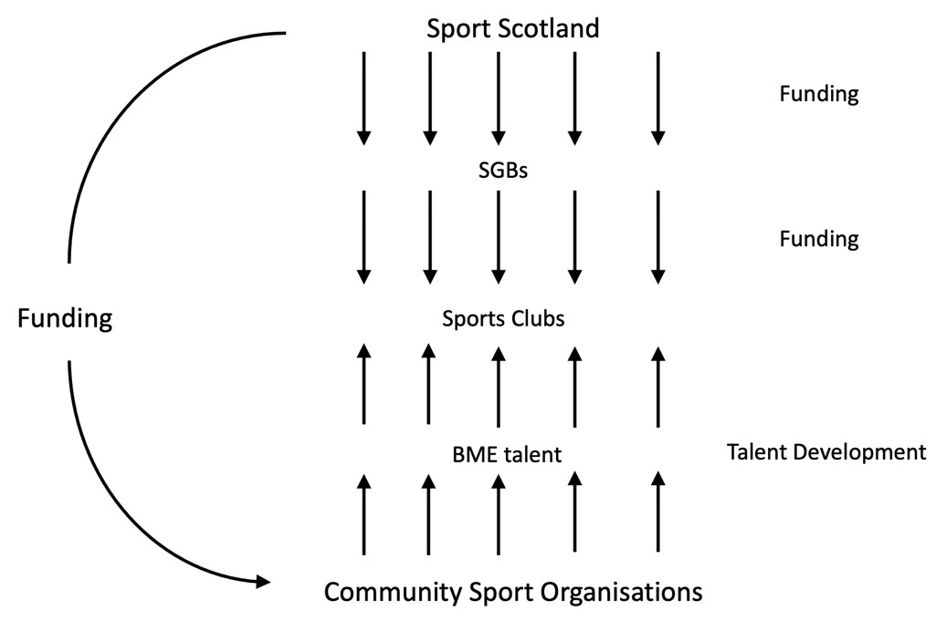
A simple model that emerged from one of the consultations, (Figure 1) suggests the need for the following flow of resources:

Fig. 1: Proposed structure for supporting sport development within ethnically diverse communities

It was suggested by different individuals involved in this consultation that perhaps organisations representing ethnically diverse communities often do not get funding for their work because of historical reasons – that already existing relationships are prioritised because of their positive track record and experience of the system. It was suggested that there could be a pot of money ring-fenced for working with these communities for which an expert panel with knowledge of those communities and the issues they face should be set up to make those decisions.
This approach would need careful management, as does any positive action around ethnicity, to avoid accusations of excluding community organisations working with the white majority whose needs are just as important and who are also chasing scarce resources.
Structural Barriers to Participation
Different organisations encourage participation for different reasons: to meet policy directives connected to a healthy and/or socially cohesive communities or increasing the talent pool ultimately for international recognition and national pride. In recent years a distinction has emerged between sport development and sport for development. Sports clubs are often seen as a primary part of the sport development infrastructure whereas community organisations will utilise sport as a tool for engagement with other social and personal development aims as the explicit outcome, rather than increased sporting ability as the ultimate aim.
Part of the problem for CSOs is access to facilities. Particularly contentious is the way that council leisure services take control of school facilities. Either the school facilities simply are not made available any more due to safety and security issues for which caretakers are no longer employed to oversee or they are managed by the city council leisure services whose priorities are perceived to be more commercial than community centred.
Further structural inequalities remain through what is perceived to be a tokenistic approach that fails to recognise the full diversity of ethnically diverse communities. “They align with one community group who's very subservient, are aligning with their status quo, and they keep feeding a bad kind of a habit.” (Participant 10). Equality is seen as an add on rather than embedded within sporting infrastructure:
And for those organisations that do develop a good working relationship, it leads to a dependency culture that many participants criticised as it reinforces structural inequalities that their organisations are trying to overcome.
“what we bring to the table… is we can bring a lot of BME kids… and then we're hoping that they've get maybe a strategy or they've got funds in place to maybe hit that area of work, if that makes sense. So we're kind of relying on that and then hopefully that puts things into place and we can start doing things together.” (Participant 4)
If SGBs have targets and want to reach them, they need a better understanding of which sports clubs are willing to engage in such a process and help build the infrastructure to do so, in terms of offering conditional funding and encouraging appropriate and equal partnerships between sports clubs and ethnically diverse community organisations at the local level.
Intersectional cultural barriers to participation
There remains a lack of understanding amongst those running predominantly white sports clubs about how their comments and actions can make members of ethnically diverse communities feel excluded. For one community organisation, Netball was proving to be popular amongst South Asian girls and women but, “…when they go to tournaments and some of them are wearing headscarfs… everybody's just looking at them like they've never seen them before or something…” This makes participants feel uncomfortable but the positive outlook is that, “they're on a team where they all like look the same. They've all got a sense of belonging.” (Participant 4)
A sense of belonging was also seen as crucial in encouraging boys to participate as well with racism in various subtle and ignorant forms still a problem within predominantly white sporting cultures:
“we've been told by a lot of kids [that if] they go to [other] teams they feel like they just don't belong, really. And the coaches, they don't bother with them. So, I feel like a barrier is just not having enough opportunities and not enough people that they can relate to, not enough role models either [within community sport].” (Participant 4)
There were further distinctions made between established ethnically diverse communities such as those with South Asian heritage and more newly formed communities from, for example, West Africa, the Middle East or Eastern Europe – both in terms of their needs and their perspectives on sports participation. There are also common experiences about “not feeling comfortable in a place where they’re a visible minority,” especially if they’re, “not spoken to respectfully…” (Participant 2).
This is a deeply ingrained history of structural racism within society and its social institutions at large of which members of established ethnically diverse communities are aware but still feel powerless to change (see section 5):
“I don't want to get too deep, but that maybe feeds partly into a Colonial sort of mindset, you know. [Some people] often still think in those terms: you know, of just being… happy that people aren't being openly racist to you. Basically, you aren't getting called the P word in the street.” (Participant 2)
In contrast, attitudes from members of more recently arrived communities are reassuringly naïve in that they see opportunities for changing the system rather than focusing on extant barriers. This is in part because of the decades of activity by the more established communities who have gradually informed and generated change.
The ‘New Scots’ as they have been labelled within policy documentation, have not experienced such structural prejudice over generations. They do though face barriers. But by existing in a more open and diverse society than their predecessors, they want to make sure the talent is given opportunities to progress just as much as having recreational opportunities.
“many of our young people who are talented… are not being showcased… these are brilliant young people who are talented, but you can hardly see them… So that's one thing. Another thing is that the sports activity in Scotland [is] so expensive... If you don't have the resources, that means your child will not be able to do what he or she is passionate about doing...” (Participant 3)
Sport Development & Sport for Development – Different Needs, Different Structure
As schools have increasingly had to outsource their sport provision, community sport organisations have often been engaged because of their existing role within the community but the question is, why are they not being funded directly. One participant asked, “[Why can] I not go to the Active School to say, ‘the kids that I'm already taking care of are in your school. Can you raise an invoice to the council for them to pay me for the work I’m already doing?” (Participant 8)
This leads to, or adds fuel to, suspicions about the system:
“The Active School themselves [has] probably got like people who does not even [do as much as] what we've been doing. Meanwhile, you're already doing work in that community that involve kids from all around the school, but you don't get paid for it.” (Participant 8)
This is expressed in a fairly subtle and perfectly valid manner by a participant representing a local sports club, who despite being predominantly white are very open to widening their membership to ethnically diverse communities but suggests that, “it's more fundamental than, you know, ‘it's not available to diverse communities.’ It's just not available to communities.” (Participant 5).
The impression is that there are a lot of challenges to participation in sporting activity more generally beyond issues relating to ethnicity or culture –
“I think from rugby’s point of view... They're just concerned about getting bodies, right, and ethnicity is neither here nor there… We’re short of players, we’re short of coaches, we’re short of volunteers, you know. And it doesn't really matter where they come from. We just need more.” (Participant 5)
At a structural level it might seem that neglect for community sport is the issue as reliance on volunteers and the bonding capacity of sports clubs has changed in recent decades. But engagement with ethnically diverse communities should be an embedded part of reenergising community sport because within such communities there clearly already is a strong culture of community activity. What is missing is the cultural connections across different ethnic backgrounds.
There is also an issue relating to communication of the funding structures that may be available and being transparent about where the money is coming from.
“The only funding that we've got in to assist these people to get this qualification, [their] coaching badge… is mainly from the trusts. And if anything is coming from sportscotland, maybe it's coming in the name of something else because I don't know.” (Participant 8)
Consideration also needs to be given about how such organisations might operate in the long term because the current funding structures do not seem to take into account the amount of time needed to make applications.
“We're kind of getting small pots of funding, but… it's not like, you can start planning for things. I’m almost playing it week by week… some people do send us like big, long lists of funding we can apply for. And it ends up just you filling in a form and then you just don't hear back… that is probably the biggest barrier, just not having enough funding to do things.” (Participant 4)
The community sport organisations that represent ethnically diverse communities are not large enough or well enough resourced to have fund raising officers, which is what is required for third sector organisations to be sustainable in the long term. So once again, there is a desire for a more formal route through which funds from within sport can be channelled to fulfil the widening participation agenda in a more direct way.
2) Relationship Building, Bureaucracy and Communication
Whilst widening participation directives seem to have ignored the role of the community sport sector (as discussed in section 1), within sports clubs themselves it is often down to the desire of individual members to be proactive in increasing interest within ethnically diverse communities.
“We will go out and speak to other black and ethnic minority organisations… For example, there was a particular group that was all women and we said that anytime you want to bring your membership to our club, just tell us where, when and how… we would make sure there were no men there at all.” (Participant 1)
It is, however, highlighted that this is difficult to achieve without appropriate support. Sports clubs’ board members and administrators take on their duties as volunteers and only have so much time to devote to their roles. The extra work involved in promoting offers such as the example above involves greater commitment.
Whilst the actual act of accommodating the cultural needs of a specific group, such as Muslim women, may be relatively straight forward, there is the need to build the relationships and trust in the first place, which takes time, even from within the community. That trust exists because, “…when they come [we] look alike, they can associate very well [and] we can understand the challenges faced by the community.” (Participant 9)
It is not only the positive associations that are made by taking a bottom-up approach to engaging with (different elements within) ethnically diverse communities but the perception that top-down approaches are constrained by the procedures that are rooted in traditions which have never considered other cultural needs:
“If you ask a mainstream organisation, ‘could you accommodate an Asian female who wears a scarf?’ Oh, there will be three months of planning and meetings and then oh… health and safety rules say that that's something we can't do. So, we have to remove all the bureaucracy…” (Participant 10)
Whilst community sport organisations have to some extent replaced schools as providers of recreational sporting activity, schools are still seen as primary gatekeepers for engaging with young people.
According to sportscotland, “Active Schools aims to provide more and higher quality opportunities to take part in sport and physical activity before school, during lunchtime and after school, and to develop effective pathways between schools and sports clubs in the local community.” The Active Schools coordinators are employed to build capacity through the recruitment, retention and development of a network of volunteers to deliver sport in line with the priorities and outcomes of the Active Schools initiative. Such partnership working reveals tensions in this instance between CSOs that are seeking direct support to deliver sporting opportunities on their terms and Active Schools which, in the case of engaging ethnically diverse communities, is failing to offer added value to the partner organisations they are trying to engage to help deliver on their aims and objectives.
There is a feeling from some that sportscotland do not know of the existence of or understand well enough the purpose of community-based organisations and consequently have no idea of the impact they are having on increasing sport participation rates (at the recreational level at least) or raising sporting aspirations amongst ethnically diverse communities. That sportscotland have commissioned this report is recognition of this, but it is important that those engaged in these consultations are kept informed of progress and made aware of the timelines involved in trying to create change in whatever way that might emerge from this process. As one participant highlighted:
“The only time I've experienced sportscotland was when I received an e-mail from an Active Sports coordinator… I received the e-mail [which] said, ‘could you please tell me the numbers of males participating in football; the number of females participating in football? We want to send these details to Sports Scotland.” (Participant 8)
Community organisations have been widening participation for a significant period of time but have been doing it in spite of the challenges that persist and without acknowledgement from mainstream sport organisations. The sporting authorities want to (more formally) increase participation amongst those communities but have not (as yet) done enough to engage with and support those that are already doing the work. This leads to suspicion when a sudden interest is taken, without building the appropriate relationships and working in partnership to achieve mutual aims.
At a fundamental level, there is a lack of knowledge from those involved in the clubs themselves about how to reach out to such communities. Likewise, for community sport organisations there is a lack of knowledge and opportunities to develop relationships with the appropriate members of organised sports
The role that sportscotland or SGBs need to take is as a cultural intermediary through directly funding programmes that encourage cultural exchange rather than the employment of individual cultural intermediaries such as Active School coordinators. They need to understand that to encourage people from ethnically diverse communities to feel comfortable in predominantly white sporting spaces at the same time as helping predominantly white sports clubs feel comfortable reaching out to ethnically diverse communities and their community sport organisations, is to put programs in place that encourage relationship building over time on an equal basis.
Sports clubs can grow their presence slowly amongst such communities and community sport organisations can gradually familiarise their participants with the sports clubs. But as one participant highlighted, “[we] need to look into how we collaborate; collaborate on [an] equal footing, where you have a say – you're not just subservient to the mainstream organisation because you are expert with the community.” (Participant 10)
Crucially there was acknowledgement that sports clubs and governing bodies might already be trying to do these things but that nobody was aware of it. Furthermore, there was a lack of awareness of sportscotland and thus the structure of sport in Scotland:
“I've been very active myself in terms of sports. I ran a badminton club here for about 10 years… I'm a qualified coach for Badminton [but] in all my years I've never heard of sportscotland… I would have thought I was quite embedded in sports… But I had never heard of sportscotland in a way that I could understand until, you know, some of the issues with Cricket Scotland.” (Participant 10)
3) Pathways to success

The nature of community sport is that the organisations involved tend to set themselves up to overcome barriers related to their ethnicity that go beyond sport and reflect inequality within other aspects of society. They are in some ways structured by the funding available to them but as they become more experienced and better established they gain expertise that places them in a good position to help other organisations reach their targets as well as being encouraged by certain funding structures to work in partnership with more ‘mainstream’ organisations.
However, they then encounter barriers to their development as other structures are not necessarily aligned with the bottom-up nature of community development approaches that have developed organically from the grassroots upwards. As they grow and want to expand through using their expertise in working with disadvantaged groups, they encounter structures that are imposed from the top that are designed to help widen participation but in fact suffocate these kinds of organisations’ development and undermine the very aim of increasing sporting engagement.
There is both a feeling that they have to do everything themselves, with little support, but also that they want to do everything themselves because they have been the ones committing the time already, are best placed to continue such work and have an organisational identity that they wish to maintain.
One workshop participant wanted to make clear, “There is a feeling that mainstream sports organisations get in touch because they have targets to meet rather than because they actually want to widen participation: “I get calls from all sorts of people [saying], ‘We are running training. Could you send me some ethnic minority, we don't have any.’ So we're still in that culture.” (Participant 9).
The alternative culture that these organisations would advocate for is one where those already working with ethnically diverse communities are supported to develop their own expertise beyond what they have been able to so far in order to offer pathways within as well as beyond their own communities. Current structures mean that the talent cannot be developed well enough within community sport environments because it costs money and cultural barriers still exist due to other responsibilities and commitments that take precedence for diverse ethnic minority parents.
The solution from within the community is that they want to be able to do it themselves because they have the cultural expertise but there is not money for an ethnically informed talent identification and staff development programmes.
That is not to say that CSOs are not trying to offer what they can because,
“over time we've got all of these young kids together. And sometimes when they're like 17 [they] outgrow the programme. Now what is next? You need a pathway for these kids. And that is why you must be able to link to mainstream services [so that] once they are done at youth level, they begin to progress. All the skills they have acquired over time, not just on the pitch, but outside the pitch, so we have a leadership mentoring programme for these kids.” (Participant 8)
There remains a lack of awareness of what the sport industry can potentially offer for those that are interested in sport, especially within some cultures:
“Especially our community, like, money is a big factor… you want to get a good job, like Doctor, Lawyer, dentist, whatever… or we know some that have volunteered with us, they've ended up being like barbers and they can make a lot of money doing that… sports is probably the bottom of the list, to be honest…” (Participant 4)
This participant was open about their own pathway and admitted that they used to attend sessions before then volunteering and after working elsewhere and being made redundant, was lucky enough to still be involved when an opportunity arose but is only in the role for a short time before going to university to train as a teacher. This is because there is, “no pathway into coaching…” The lack of existing coaches from ethnically diverse communities, especially South Asian, makes sport seem like a, “really unrealistic area to tap into if you want to make a living.” (Participant 4)
It is a vicious cycle that requires a step change in approach to break. Ethnically diverse communities need to see members of their own communities succeeding within mainstream sport but because mainstream sport does not have enough ethnically diverse people at the top the barrier remains:
“we are trying to get South Asian or, like, brown coaches so the kids can relate to them. Just having somebody that they can like look up to and kind of see as a role model. That kind of helps… so, we try and target coaches like that, but there's only so much interest you can get from coaches of our background.” (Participant 4)
At a more fundamental level this is summed up as not just about, “getting a black or brown face on the board. It's the structure that that person, whoever that person is on the board, is representing. So the structures below need to feed up, and it needs to feed down.” (Participant 8)
Solutions differ between established and newly forming ethnically diverse communities. For the former, there is a feeling that to some extent the infrastructure is already there due to established community sport focused organisations. As a consequence, there is frustration at not being recognised for what they provide and what is needed for further development.
4) Wider attitudes towards EDI as practice (core understandings of diversity)
Community Sport Organisations are widening participation amongst ethnically diverse communities, at a recreational level at least, but often through a sport-plus or plus-sport model linked to SGB targets. This development has been met with varying levels of scepticism and enthusiasm by those running community sport organisations.

Some see widening participation as performative, focusing on the production of policies and documents that are published on the website as a replacement for engaging with the communities who are affected. Others see EDI officers failing to engage or offer solutions to engagement. Whilst others prefer to look at the positive developments that have taken place in recent years..
“I think a lot's happened over the last few years, especially in Scotland in terms of people recognising that there is a need to address institutional racism within certain organisations and systems. There was obviously the high profile case of Cricket Scotland…In my eyes it's a huge positive that these things have come out into the open… I think generally that things have got a lot better and they're improving but it's just a frustration that people still feel uncomfortable in certain spaces.” (Participant 2)
It seems that negative occurrences are still very much part of young people’s experiences of playing competitive sport in Scotland (see section 1): “Sometimes we'll play certain teams from like areas of poverty and stuff where, well, these things are almost normal, but they get a lot of racist remarks and you get a lot of people trying to basically fight them and try to cause trouble.” (Participant 4).
And whilst, “there are like procedures in place to report things and for things to get taken care of… [which is] probably a good thing,” they are not necessarily straight forward either. There is a feeling that the procedures are almost designed to make it difficult to report such incidents and that because of the lack of real concern about such incidents within the authorities, following the procedure becomes more important than getting to the crux of the problem.
"…if you miss a step or you don't do something following the book, it almost gets thrown out… when you're in that situation, because I've been there before myself… you can't think clearly… so the fact that you need to like, think logically, ‘What's the steps? What's the procedures?’ Do you know what I mean? It's a hard thing to do.” (Participant 4)
This participant acknowledged the progress in having such procedures in place but because, “a lot of the people on the board are from a white background,” there is a lack of appreciation as to the immediate affects and, thus, the difficulty of attending to procedural requirements because, “there's not really anyone [in authority] that's probably been through it.” It is, of course, important to make sure that a robust process is in place for reporting such incidents and that action is taken, and staff are equipped to deal with incidents.
There is a a need for members of ethnically diverse communities to be present throughout the sporting infrastructure in order to respond to issues due to their lived experience and to reassure others within their communities that decisions are being made for the correct reasons and that it is possible for those ‘that look like us’ to influence those decisions. As one participant put it, it is about, “Removing barriers intentionally. That unconscious bias nonsense. I [prefer] conscious inclusion. You need to consciously include people if you really want to move. And that's what the mainstream is missing.” (Participant 9)
There is also a deeper concern that more established communities are no longer seen as a priority even within the tokenistic cultures of equality that do exist. Expanding on this they say:
“Now, if you're a young person growing up from a South Asian background, nobody wants to know you. You're off the list these days in this country… [Our] communities have been living [in Britain] for a long time... Some are moving in the right direction, some are not... Every funder now wants to fund black community projects.” (Participant 10)
For this person, their community is both still predominantly excluded because of their ethnicity but not recognised as being as excluded as other communities, creating a hierarchy of inclusion. These comparative feelings must not be ignored but may need greater understanding within the intersectional identity politics that has emerged in recent years and has made the community sport landscape even more complex to navigate.
“everybody's opening up their own, wee small community groups… Even sportscotland will be very happy to fund a black organisation at this moment [rather] than any, probably Pakistani or Indian… Because they're looking for visibility in the public domain. [Because of what] it says in the media, they are basically dictated by visual outlook, which worries me because you are promoting inequality within the equality spectrum.” (Participant 10)
What should be pointed out is that regardless of whereabouts a community might (perceive itself to) be within such a hierarchy (if such exists) seeing exclusion in this way is not necessarily dealing with the root causes but is in fact possibly reinforcing the culture of dependency. Funding issues are critical, due to the links between ethnicity and economic position, but solutions are need to address structural problems.
sportscotland need to understand what they are being told with regards to accessing sport but take that and place it within wider social structures and use their power to challenge other societal inequalities.
As lessons are learnt from the high profile incidents of racism reported in Cricket, there have been moves to address any issues that might exist and undertake some monitoring in other sports. A focus group member representing their sports club who has a role within the SGB noted that, “one of the things that we did try to do was to get clubs to do a little bit of ethnic monitoring. But it's how that is done is the hardest part.” There is sensitivity around asking for this information. As another member of the group discussing the ethnic makeup of their sports club noted:
“I think we’re pretty diverse. To give you a number would be hard because we haven't done… ethnic monitoring... the only thing we ask [members] for is their mobile number… if we started to ask them for anything else, people say, well, why do you need that information? And more importantly, what are you going to do with it?” (participant 1)
The important thing is to be very clear about the reasons for doing so. Implicit within the discussion is, once again, concerns about trust from ethnically diverse communities towards predominantly white sporting bodies as to the point of such an exercise. It was suggested that although direction might be sent to sports clubs to collect such information from their members, it would be better if, “the governing body sends it [directly] to each individual and explains the purpose and the reason behind it.” (Participant 1). This would override any internal politics within sports clubs around these issues.
Conclusion
Sport organisations need as clear a picture as possible of the local community landscape, who is being engaged and where this is being delivered to help create wider pathways and opportunities. sportscotland needs to create greater visibility around its role and work that is being delivered.
Alongside this Community Sports organisations need to be adequately supported through funding and facility provision to help support engagement and widening sports provision across all ethnically diverse communities.
There is a need to raise awareness around subtle forms of racial prejudice, microaggressions and have mechanisms in place where organisations are trained and supported to tackle these issues. Alongside this greater transparency is needed around how funding is distributed and widening of access and support around this.
Diversity and Inclusion Action Plans should help monitor recruitment, data collection, and workforce profiling making everyone responsible for EDI - not just a particular job role or department. This needs to be supported with diversifying workforce, volunteer, coaching and player profiles and monitored to support wider systemic change.


Scottish Government (2018) New Scots: refugee integration strategy 2018 to 2022. Available at: https://www.gov.scot/publications/new-scots-refugee-integration-strategy-2018-2022/
https://sportscotland.org.uk/schools/active-schools
There is a distinction between traditional sport development models which had the aim of developing the sport for its own sake, ‘sport-plus’ development which attached to the development of sport for its own sake other explicit social outcomes from which participants could benefit and ‘plus-sport’ which focuses more fundamentally on social welfare using sport as a ‘hook’ to attract appropriately targeted populations. [Coalter, F. (2007) A wider Social Role for Sport: Who’s Keeping the Score? Abingdon: Routledge]
https://www.cricketscotland.com/changing-the-boundaries-one-year-on/

